**TECHNICAL AIRCHITECTURE/STACK**

|  |  |
| --- | --- |
| Date | 27 November 2022 |
| Team ID | PNT2022TMID48304 |
| Project Name | Project - IoT Based Smart Crop Protection System for Agriculture |

**CLOUD DEPLOYMENT:**

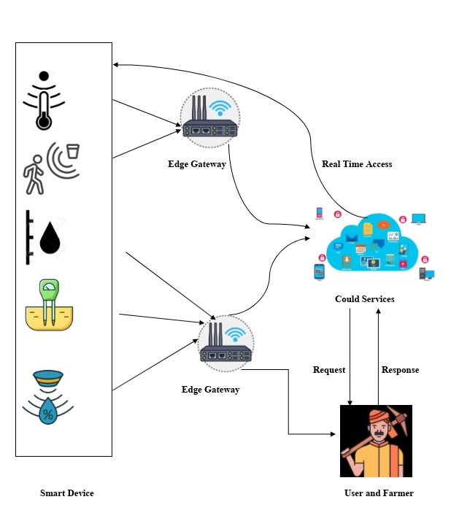

* The given architecture diagram can be divided into several different modules.
* The diagram shows how the process of edge computing works and also how it is different from the process of Cloud or Fog computing.
* There are basically a number of modules in this given architecture diagram. The first module is the connection between the Farmer and the Sensors.
* There are different types of sensors and these sensors and these identify and collect the data according to the predefined and set values given to it while setting it up.
* These sensors collect live data for a given amount of time and then send it to the next stage. The next module or next stage is when the data goes from the sensors to the system server and then to the router simultaneously.
* The system server is like an admin system which keeps all the data stored as a copy for the future references and other details. The system server sends the data to the router now for all the transfer of data to the network cloud.
* Using IoT technology it helps the farmers to control their fields anywhere is simple and now it is cost effective. If any problem arises, the announcement sends to mobile of farmers. The farmers can rectify the problem by through mobile.